H.T No
Regulations:
A20

Sreenidhi Institute of Science and Technology
(An Autonomous Institution)
Code No: 8EC05 Date: 18-Jan-2023 (FN)

B.Tech III-Year I- Semester External Examination, January-2023 (Regular)
DATA COMMUNICATION AND COMPUTER NETWORKS (CSE and IT)

Time: 3 Hours Max.Marks:70

Note: a) No additional answer sheets will be provided.
b) All sub-parts of a question must be answered at one place only, otherwise it will not be valued.
c) Missing data can be assumed suitably.
Bloom's Cognitive Levels of Learning (BCLL)

Remember | L1 | Apply | L3 | Evaluate | L5
Understand | L2 | Analyze | L4 | Create | L6

Part - A Max.Marks:20

Answer all QUESTIONS.

 |  | BCLL | CO(s) | Marks
1 | Define network topology? List different types of network topologies. | L1 | CO1 | [2M]
2 | Define multiplexing. | L1 | CO2 | [2M]
3 | Differentiate between circuit switching and packet switching. | L2 | CO3 | [2M]
4 | List out the functionalities of switch and router. | L1 | CO4 | [2M]
5 | Compare virtual circuit subnet and datagram subnet. | L2 | CO5 | [2M]
6 | Outline the functionalities of transport layer. | L3 | CO6 | [2M]
7 | Differentiate between LAN, MAN and WAN. | L2 | CO1 | [2M]
8 | Draw the frame format of HDLC protocol. | L1 | CO3 | [2M]
9 | Differentiate between broadcasting and flooding | L1 | CO5 | [2M]
10 | What is the role of CSMA/CD protocol in Ethernet? | L1 | CO4 | [2M]

Part – B Max.Marks:50
ANSWER ANY FIVE QUESTIONS. EACH QUESTION CARRIES 10 MARKS.

 |  |  | BCLL | CO(s) | Marks
11. | a) | Distinguish between OSI and TCP/IP Models. | L2 | CO1 | [5M]
 | b) | Describe the various guided transmission media with a neat sketch. | L2 | CO1 | [5M]
12. | a) | Discuss in detail about Analog-to-Digital conversion. | L2 | CO2 | [5M]
 | b) | Illustrate the Digital–to-Digital conversion. | L2 | CO2 | [5M]
13. | a) | Define CRC. Calculate the checksum for given M(x) = 1101011011 and the generator polynomial is g(x)=x⁴+x+1 using CRC on both sending side, receiving side. | L3 | CO3 | [5M]
 | b) | Calculate 7-bit Hamming code word received by a receiver is 1110101. Assuming the even parity, state whether the received word is correct or wrong. If wrong locate the bit in the error? | L3 | CO3 | [5M]
14. | a) | Explain in detail about IEEE 802.3 protocol. | L2 | CO4 | [5M]
 | b) | Discuss how 1-persistant CSMA differs from p-persistant? Explain. | L2 | CO4 | [5M]
15. | a) | Develop a Dijkstra’s algorithm for finding shortest path. Compute minimum cost from node ‘a’ to node ‘g’ for the given graph.  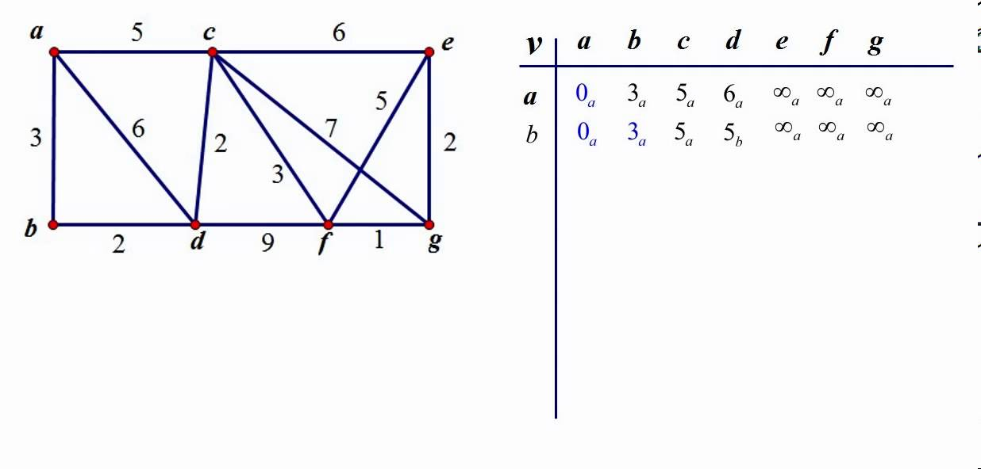 | L3 | CO5 | [5M]
 | b) | Explain how congestion occurs in the network? Discuss various congestion control mechanisms. | L2 | CO5 | [5M]
16. | a) | Draw TCP header format and explain each field in the header. | L2 | CO6 | [5M]
 | b) | Explain in detail about the operations of SMTP protocol. | L2 | CO6 | [5M]
17. | a) | List out the advantages and disadvantages of fiber optic cable. | L1 | CO1 | [4M]
 | b) | Compare Multiplexing and Demultiplexing. | L2 | CO2 | [3M]
 | c) | Describe in detail about frame format of point-to-point protocol. | L2 | CO3 | [3M]
18. | a) | Differentiate between Mac address and logical address. | L2 | CO4 | [4M]
 | b) | Explain how congestion control is performed by token bucket algorithm with neat diagram. | L2 | CO5 | [3M]
 | c) | List out the various functionalities of application layer. | L1 | CO6 | [3M]

-- 00 -- 00 –

